1. **Input:**

x=r;

Output

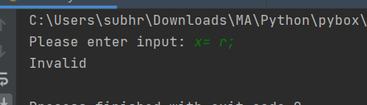

1. **Input:**

x = r; y= 7; z = x + y;

Output

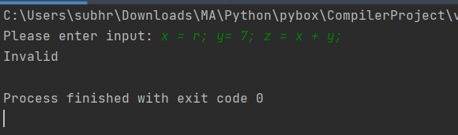

1. **Input:**

x = 3; 1= 7; z = x + y;

Output

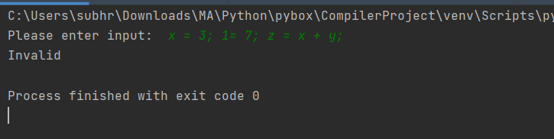

1. **Input:**

x # 3; 1= 7; z = x + y;

output

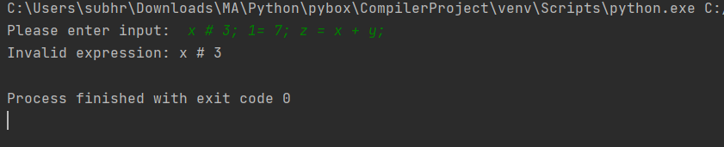

1. **Input:**

x = 0 y = 7; z = x + y

output

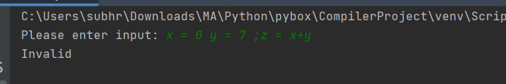

1. **Input:**

x= 3; y= 2; z = x/y

output

as divide operator is not defined

